**Configure ELB and Auto scaling in Mumbai Region**

While logged into AWS console we can able to see “VPC” in bottom of the page. Click “VPC”.

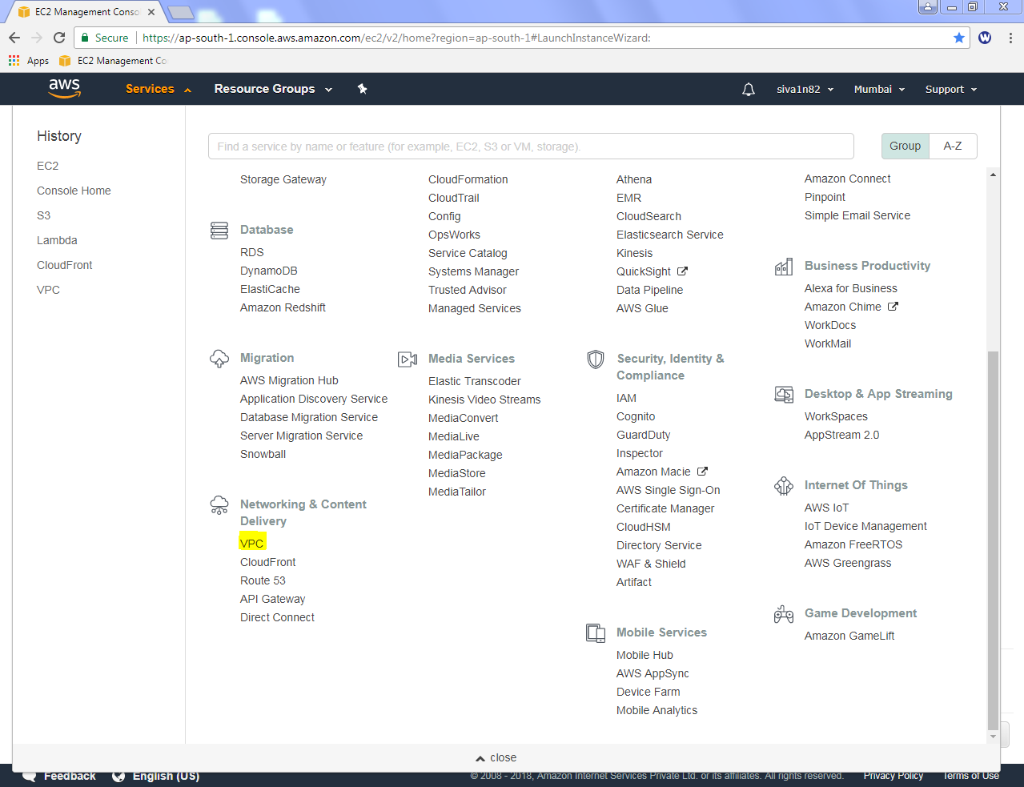

Click “1 VPC”.

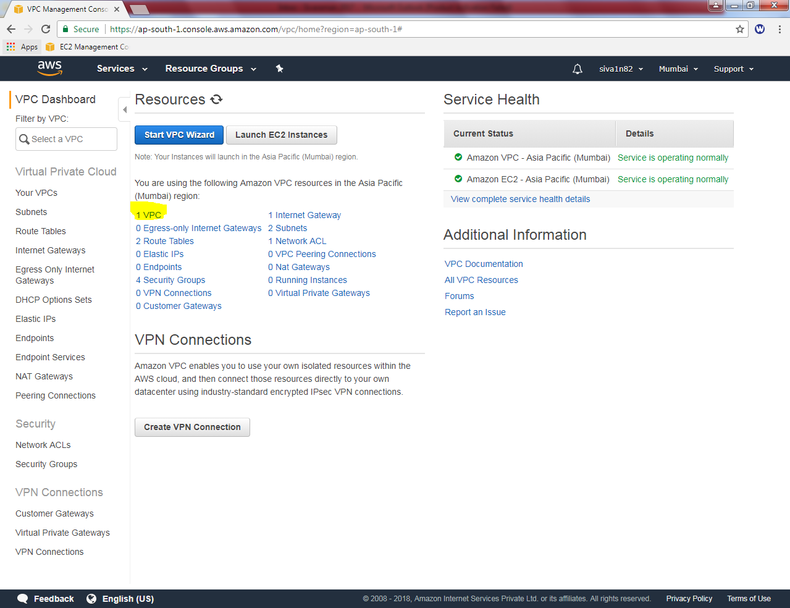

Click “Create VPC”.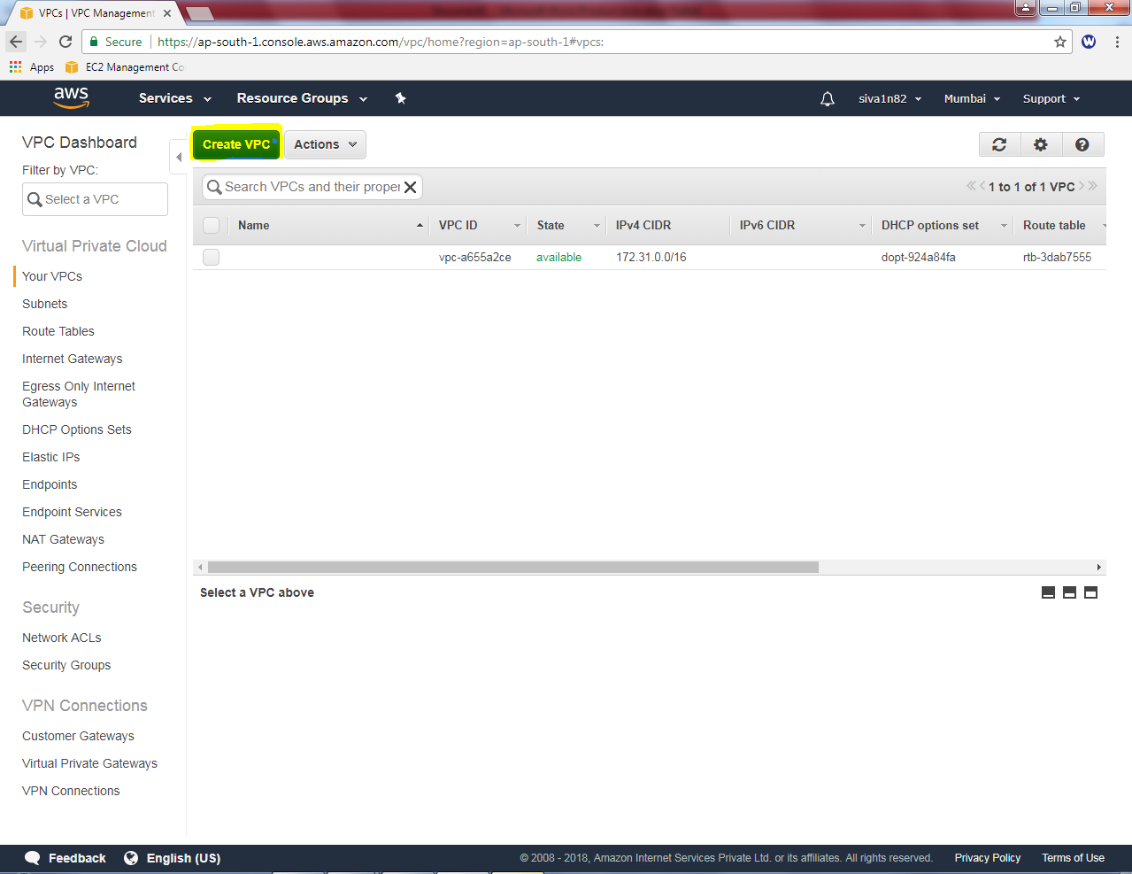

While creating VPC, name tag as “Sansbound_VPC_Mumbai”, IPV4 CIDR Block as “10.0.0.0/16” subnet then click “Yes, Create”

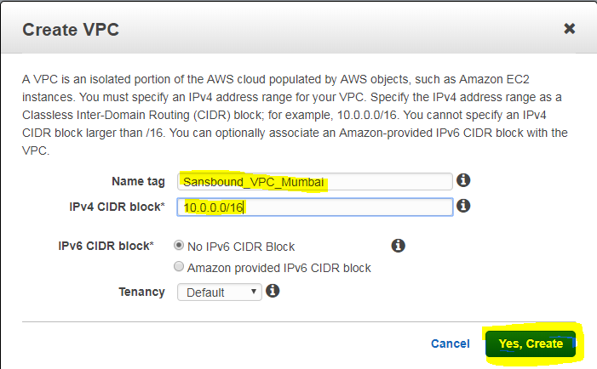

Then click subnet, click “Create subnet”.

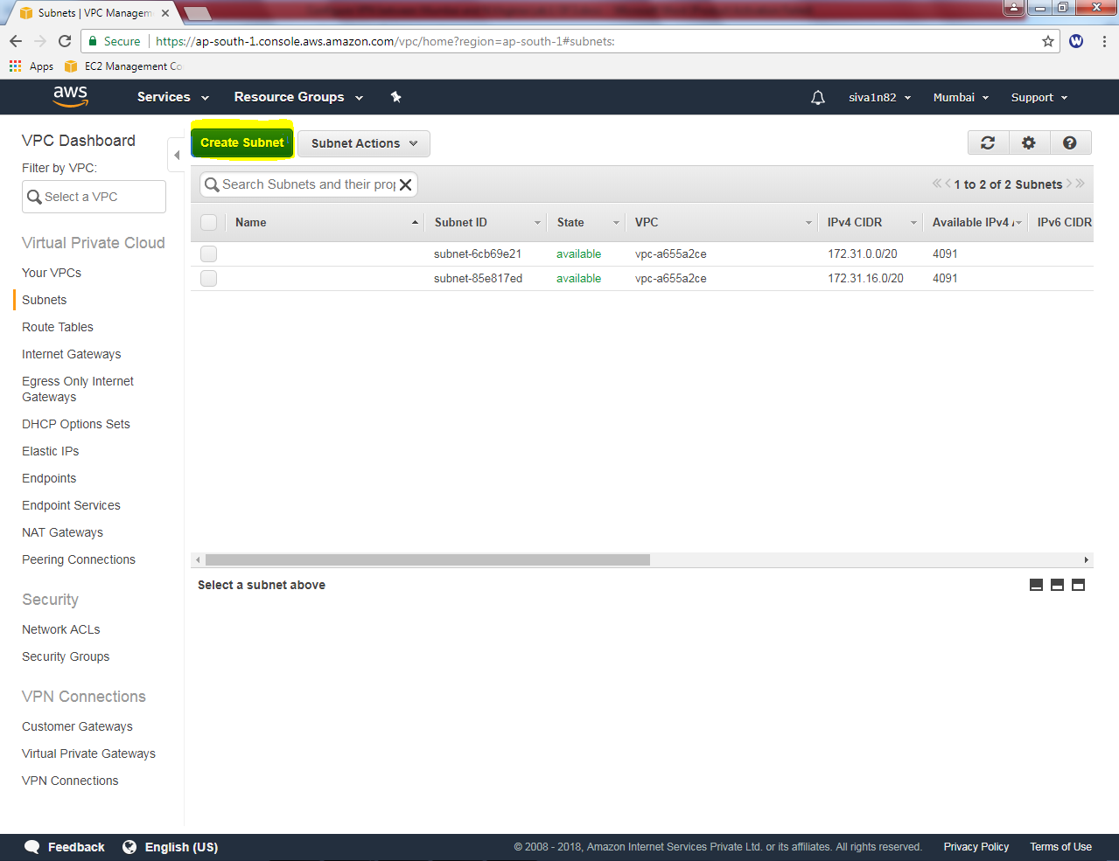

While creating subnet name tag as “Sansbound_Mumbai_Public_subnet”, select VPC as Sansbound_VPC_Mumbai , Availability Zone as “1b” (Optional) and IPV4 CIDR Block as 10.0.2.0/24 subnet then click “Yes, create”.

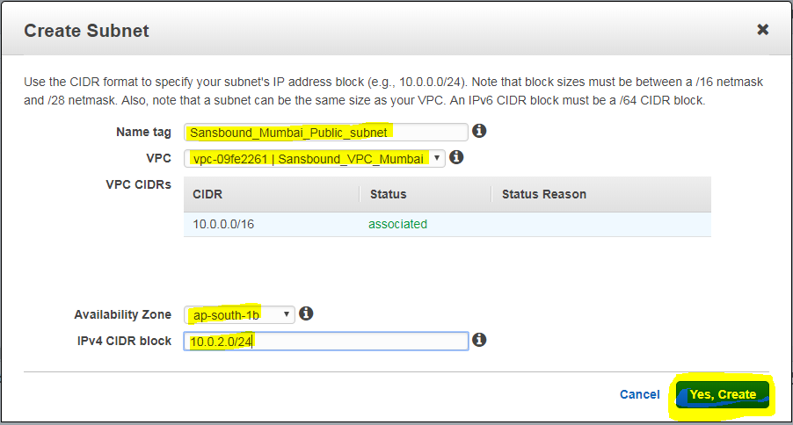

Then we need to configure Internet gateway for the VPC. Click Internet gateway and click “Create Internet Gateway” for Mumbai VPC.

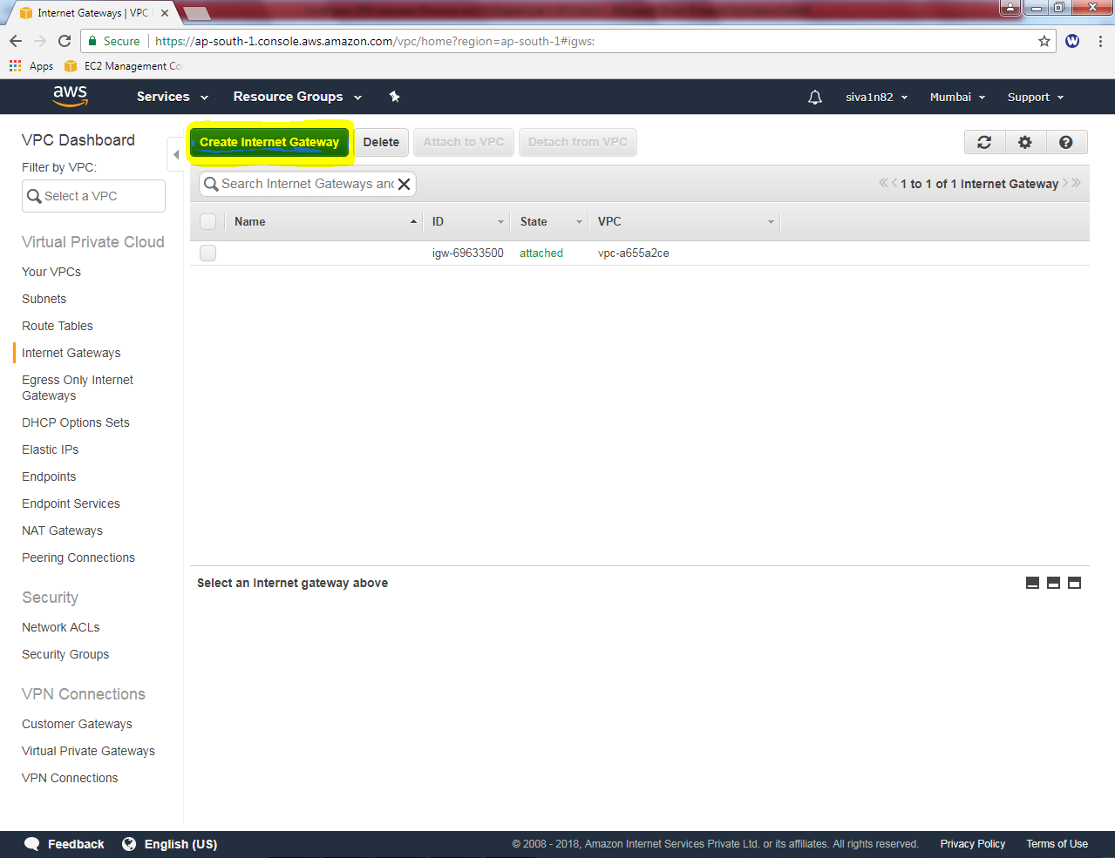

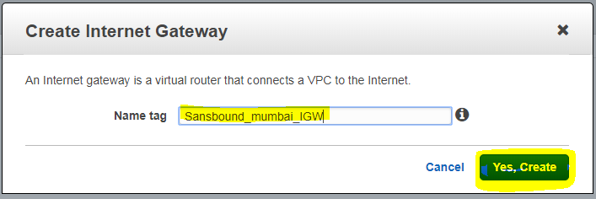

Click “Yes create”.

We can able to see that Sansbound_mumbai_IGW in detached mode. We need to attach to VPC.

Click “Attach to VPC”.

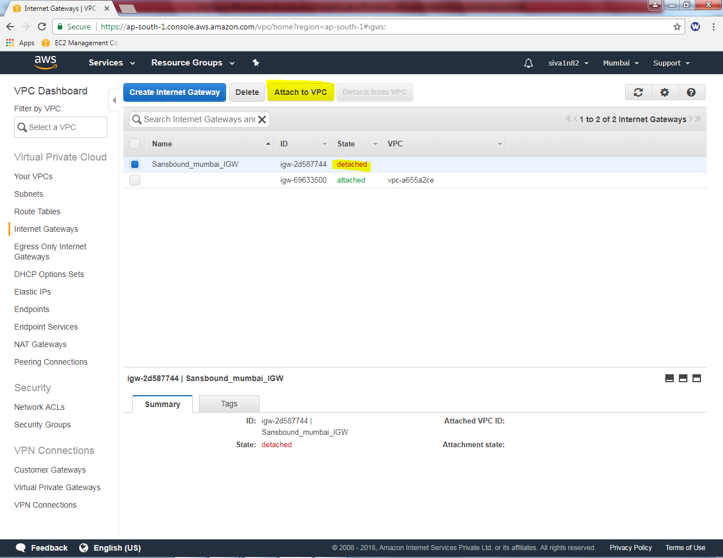

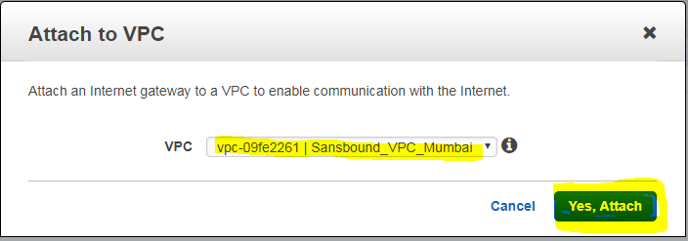

Click “Yes, Attach”.

Rename the Mumbai route table as “Sansbound_public_route”. Then click “route” tab,

Click “Edit”.

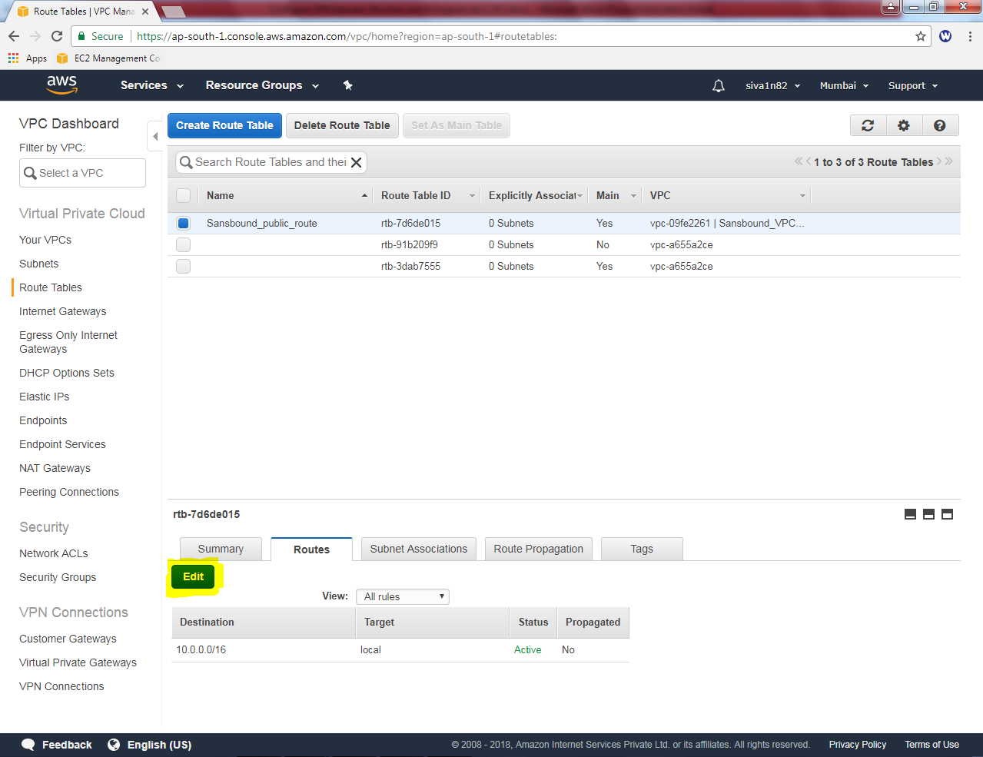

Click “Add another route”.

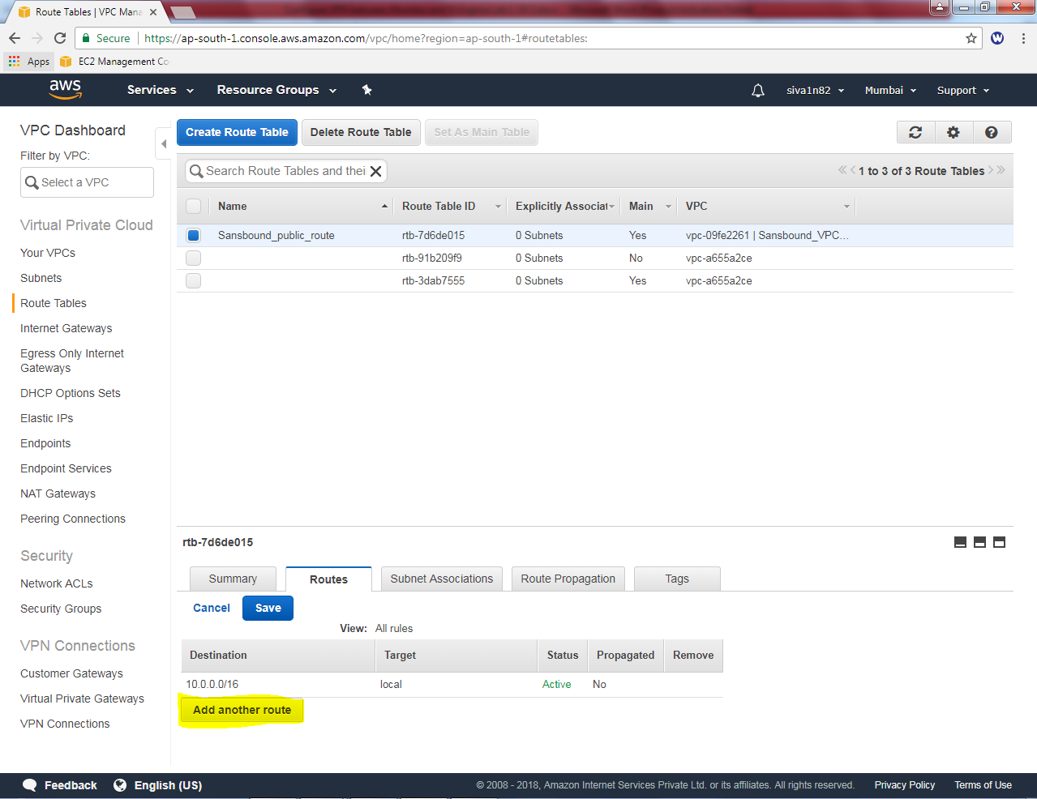

Add default route 0.0.0.0/0 and select “igw-*” as target. Click ”save”.

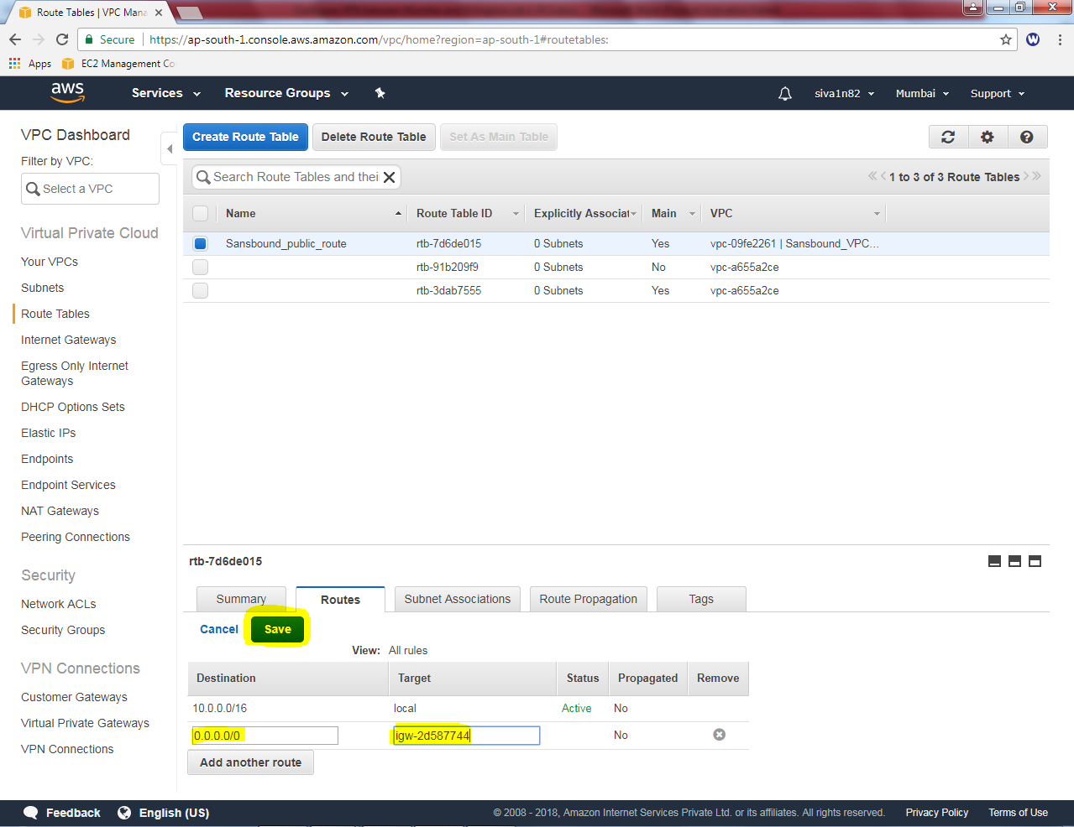

Click “Subnet associatons” tab click “Edit”.

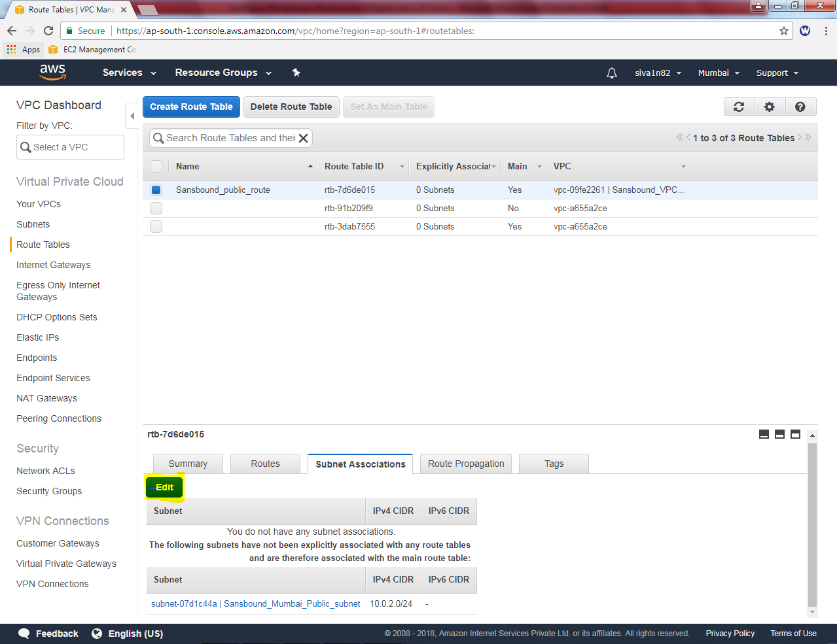

Click check box “Sansbound_Mumbai_public_subnet”and click “save”.

